**Sales Fact Lost**

1. Loading Query



**Summary Query**

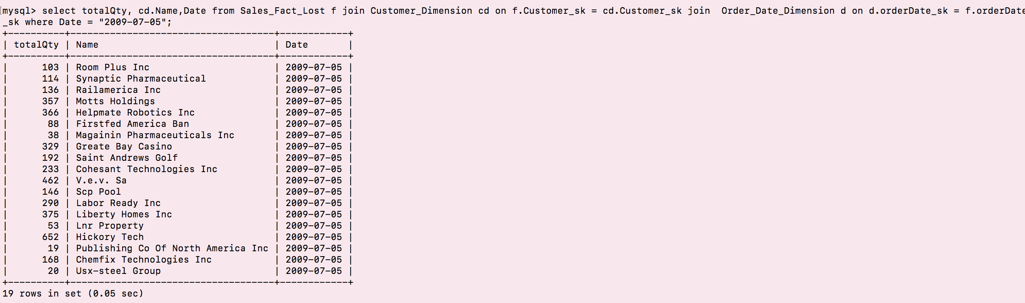



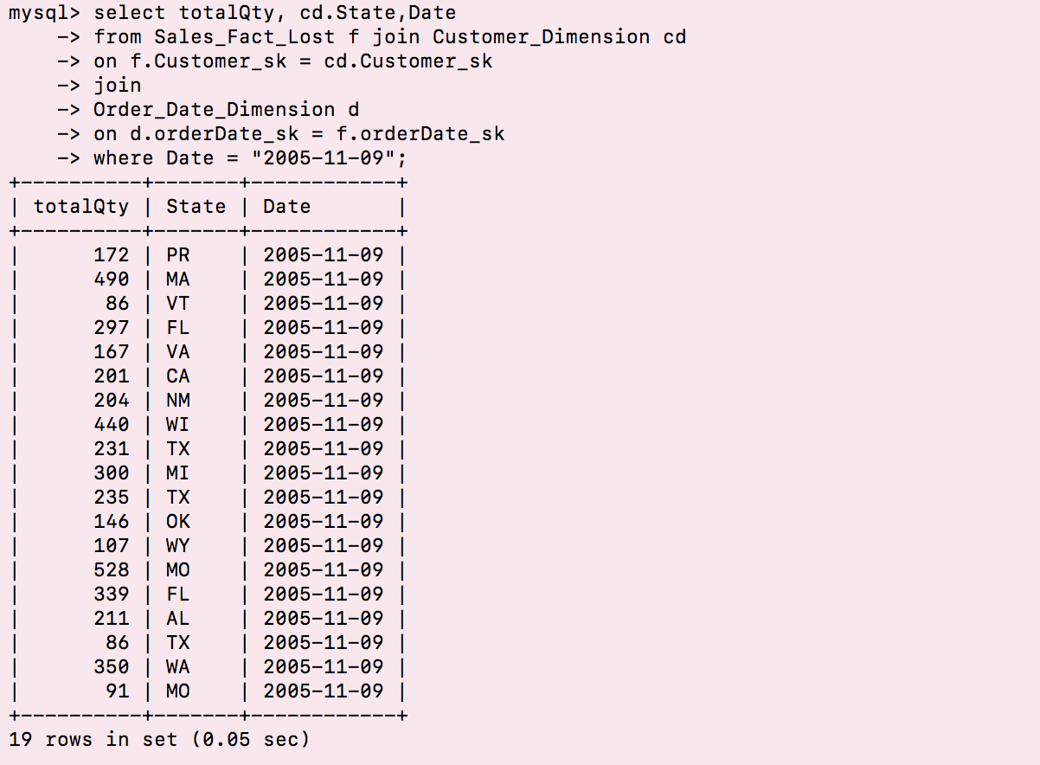

**Sales Fact Shrunken**

**Loading Query for order date monthly dimension and sales fact shrunken**

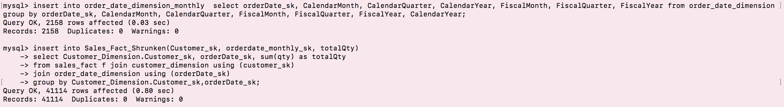

**Summary Query for Shrunken**



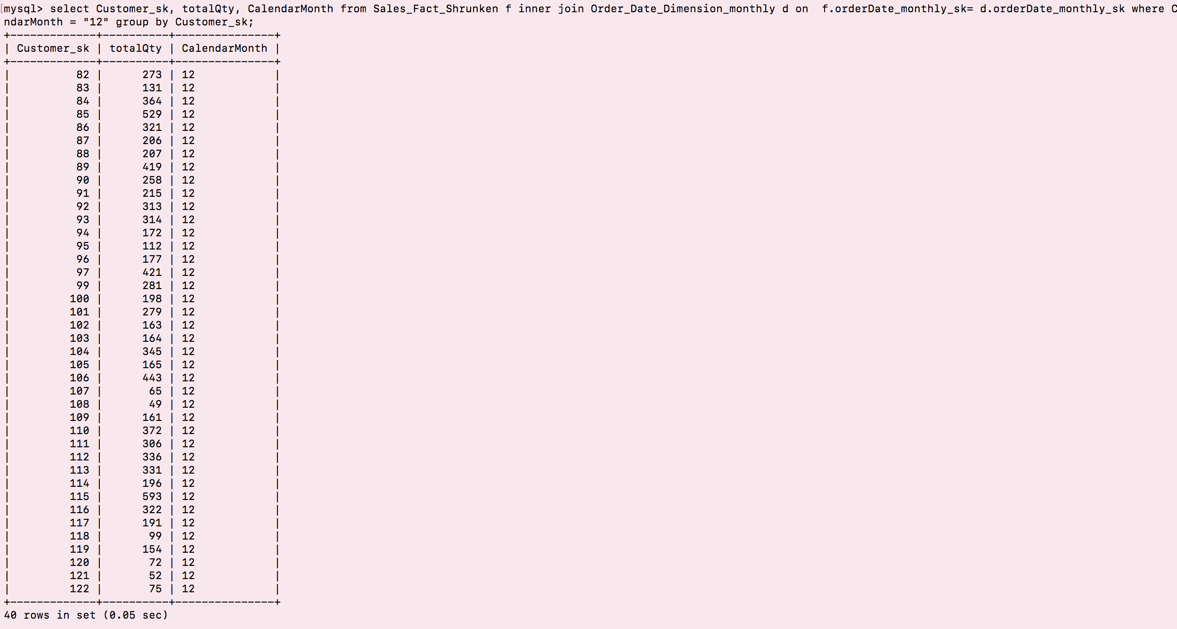



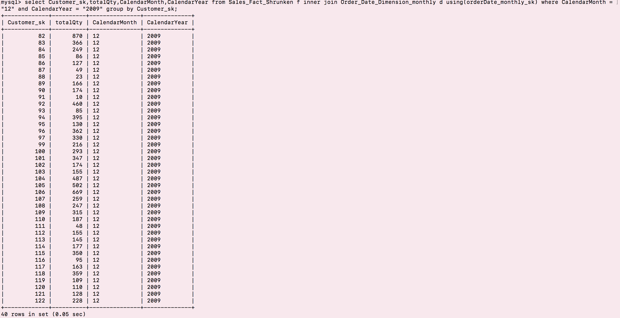

**Collapsed Fact Table**

**Loading Query**

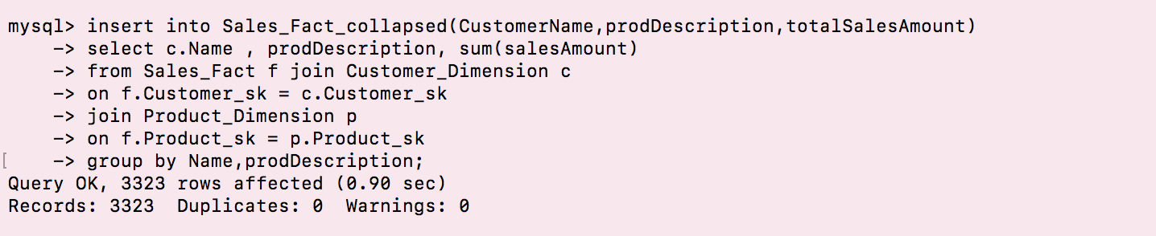

**Summary Query**







